SIMATS ENGINEERING
ASSESSMENT TOOL 2: Case Study
COURSE NAME: | Cloud Computing and Big Data Analytics | COURSE CODE: | CSA15

COURSE OUTCOME COVERED
CO3: Implement cloud-based solutions using cloud storage, web APIs, and platform services for real-world applications. (BL3)
Assessment Tool Weightage: 20%

Dave's Taxonomy: Precision (Level 3) Question Count: 3 | Total Marks: 30

Code of Conduct
I __________________Jaffrin N(192521200)____________ (Name / Reg No) certify that this submission is my original work and that I have adhered to the guidelines specified for this assessment.
I understand that any violation of academic integrity rules will result in disciplinary action.
Signature of the student: ________Jaffrin______________________

Assessment Tasks
Case Study
- Case 1: A food delivery company wants to deploy a cloud-native backend with web APIs, browser clients, and shared cloud storage for receipts and delivery images. Propose the architecture and explain the role of each component.
- Case 2: A media startup must decide between SAN-backed storage, object storage, and serverless processing for video upload workflows. Analyze the case and recommend a deployment model.
- Case 3: A smart city platform needs low-latency decision making near sensors while still using the cloud for analytics. Analyze the use of edge computing and fog computing in this environment.

Case Study Rubric
Criteria | Weightage | Level 4 - Exemplary | Level 3 - Proficient | Level 2 - Developing | Level 1 - Beginning
Understanding of Case | 25% | Clearly identifies all technical and business requirements | Identifies most requirements | Basic understanding only | Poor understanding of case
Application of Concepts | 25% | Applies suitable cloud concepts and tools effectively | Good application with minor issues | Partial application | Weak or incorrect application
Analysis | 20% | Strong analysis with clear trade-off reasoning | Reasonable analysis | Limited analysis | Minimal analysis
Solution Design | 20% | Solution is feasible, practical, and well justified | Reasonable solution with minor gaps | Basic solution | Unclear solution
Clarity | 10% | Well-structured and easy to follow | Mostly clear | Somewhat unclear | Poorly organized

ANSWERS
Cloud Computing and Big Data Analytics (CSA15) – CO3 Case Study Solutions

Case 1: Cloud-Native Backend for a Food Delivery Company

1. Understanding the Requirements
The platform must serve three categories of clients – customer mobile apps, restaurant/driver apps, and a browser-based dashboard – all communicating through web APIs. It must also store unstructured data such as digital receipts and delivery/proof-of-delivery images, handle real-time order and delivery status updates, process payments securely, and scale elastically during demand spikes (e.g., lunch/dinner hours, festival days).

2. Proposed Architecture
A cloud-native, microservices-based architecture deployed on a public cloud (e.g., containerized services orchestrated with Kubernetes) is recommended:
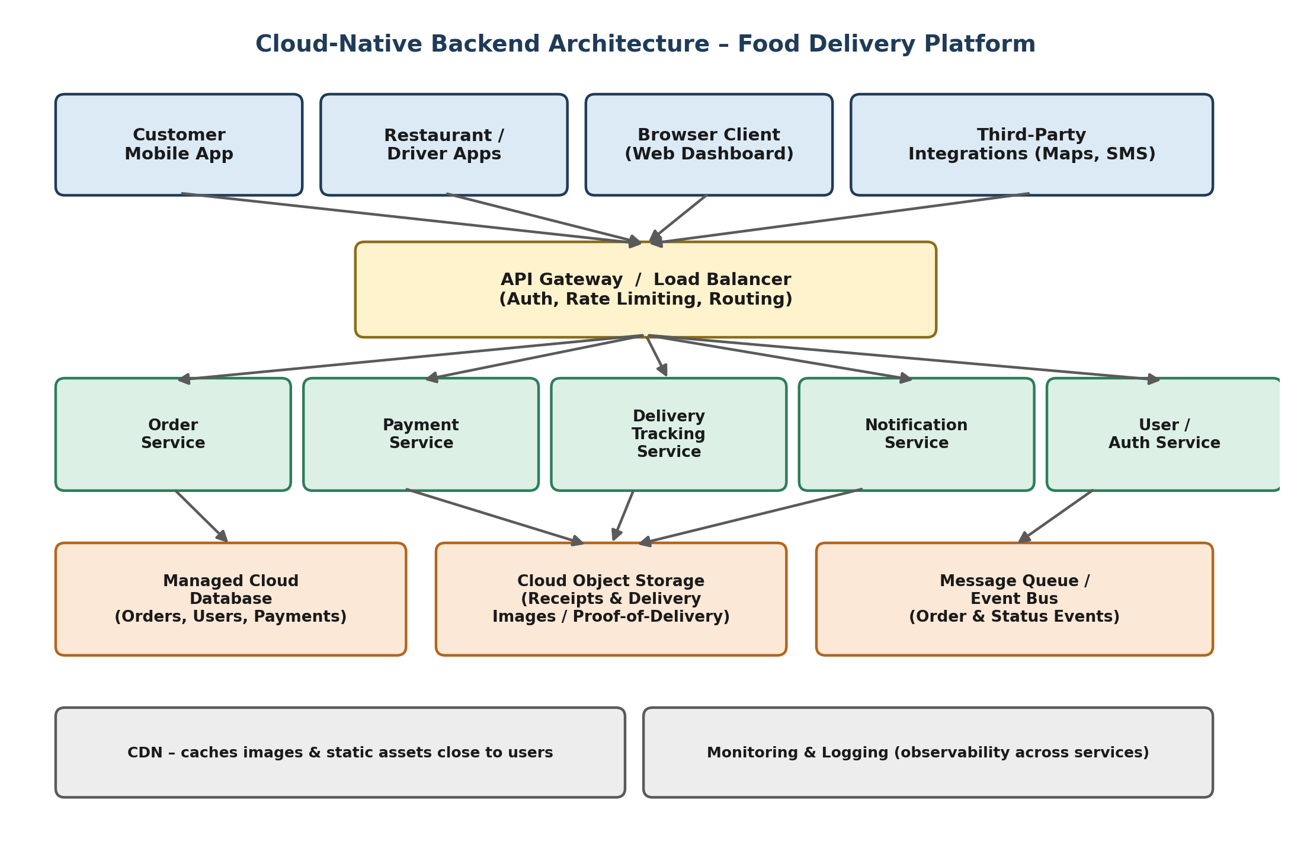
Figure 1: Proposed cloud-native backend architecture for the food delivery platform

3. Role of Each Component
- Client Layer (Mobile Apps, Driver App, Browser Dashboard): Present the UI and consume backend functionality purely through REST/GraphQL APIs, keeping the frontend decoupled from backend implementation.
- API Gateway / Load Balancer: Single entry point for all client requests; handles authentication/authorization, rate limiting, request routing to the correct microservice, and TLS termination, and distributes load across service instances.
- Order, Payment, Delivery Tracking, Notification, and User/Auth Microservices: Each encapsulates one business capability, can be developed, deployed, and scaled independently (e.g., Order Service can scale separately from Notification Service during peak hours), improving fault isolation.
- Managed Cloud Database: Stores structured, transactional data – orders, user profiles, payment records – with the cloud provider handling backups, replication, and failover.
- Cloud Object Storage: Stores unstructured binary data – receipts and delivery-proof images – which is cheap, durable (11 9's typical), and infinitely scalable compared to storing binary blobs in a relational database.
- Message Queue / Event Bus: Decouples services using asynchronous, event-driven communication (e.g., “order placed” triggers payment processing and notification simultaneously) improving resilience and throughput.
- CDN: Caches static assets and images near end users to reduce latency and offload traffic from origin storage.
- Monitoring & Logging: Provides observability (metrics, traces, logs) across all microservices for debugging and SLA tracking.

4. Why This Design Fits the Case
Because the company serves multiple client types purely through APIs, a gateway-fronted microservices design cleanly satisfies the “web APIs + browser clients” requirement. Because receipts and delivery images are unstructured and high-volume, cloud object storage (rather than a database or SAN) is the natural fit – it offers pay-as-you-go pricing, virtually unlimited capacity, and native integration with CDNs. The event-driven layer and independent microservices ensure the system can scale each function independently during demand spikes without over-provisioning the entire stack.

Case 2: Storage & Processing Model for a Media Startup’s Video Uploads

1. Understanding the Requirements
The startup needs to (a) accept large, frequent video uploads from creators, (b) process them (transcoding into multiple resolutions/formats, thumbnail generation), and (c) serve the processed video to viewers at scale – all while keeping infrastructure cost proportional to actual usage, since upload volume is likely to be unpredictable and growing.

2. Analysis of the Three Options
- SAN-backed Storage: Offers high, predictable performance and low latency because it is directly attached, block-level storage. However, it is capital-intensive, scales vertically (hardware must be purchased ahead of demand), and is not designed for globally distributed access – a poor match for a growing, cloud-based media startup with variable upload volume.
- Object Storage: Purpose-built for large binary files such as video. It scales horizontally and virtually without limit, is billed per GB stored/transferred (pay-as-you-grow), is highly durable, and integrates natively with CDNs and event notifications – ideal for storing both raw uploads and processed output.
- Serverless Processing: Functions triggered automatically when a new object lands in storage (e.g., a video upload event) can transcode or generate thumbnails without the startup managing or paying for idle servers. It auto-scales with the number of concurrent uploads, but has trade-offs: execution-time limits and cold starts, which may require chunked/step-function based processing for very large or long-running transcode jobs.

3. Recommended Deployment Model
A hybrid, event-driven model combining object storage and serverless processing is recommended – SAN-backed storage is not recommended given the startup’s scale and cost constraints:
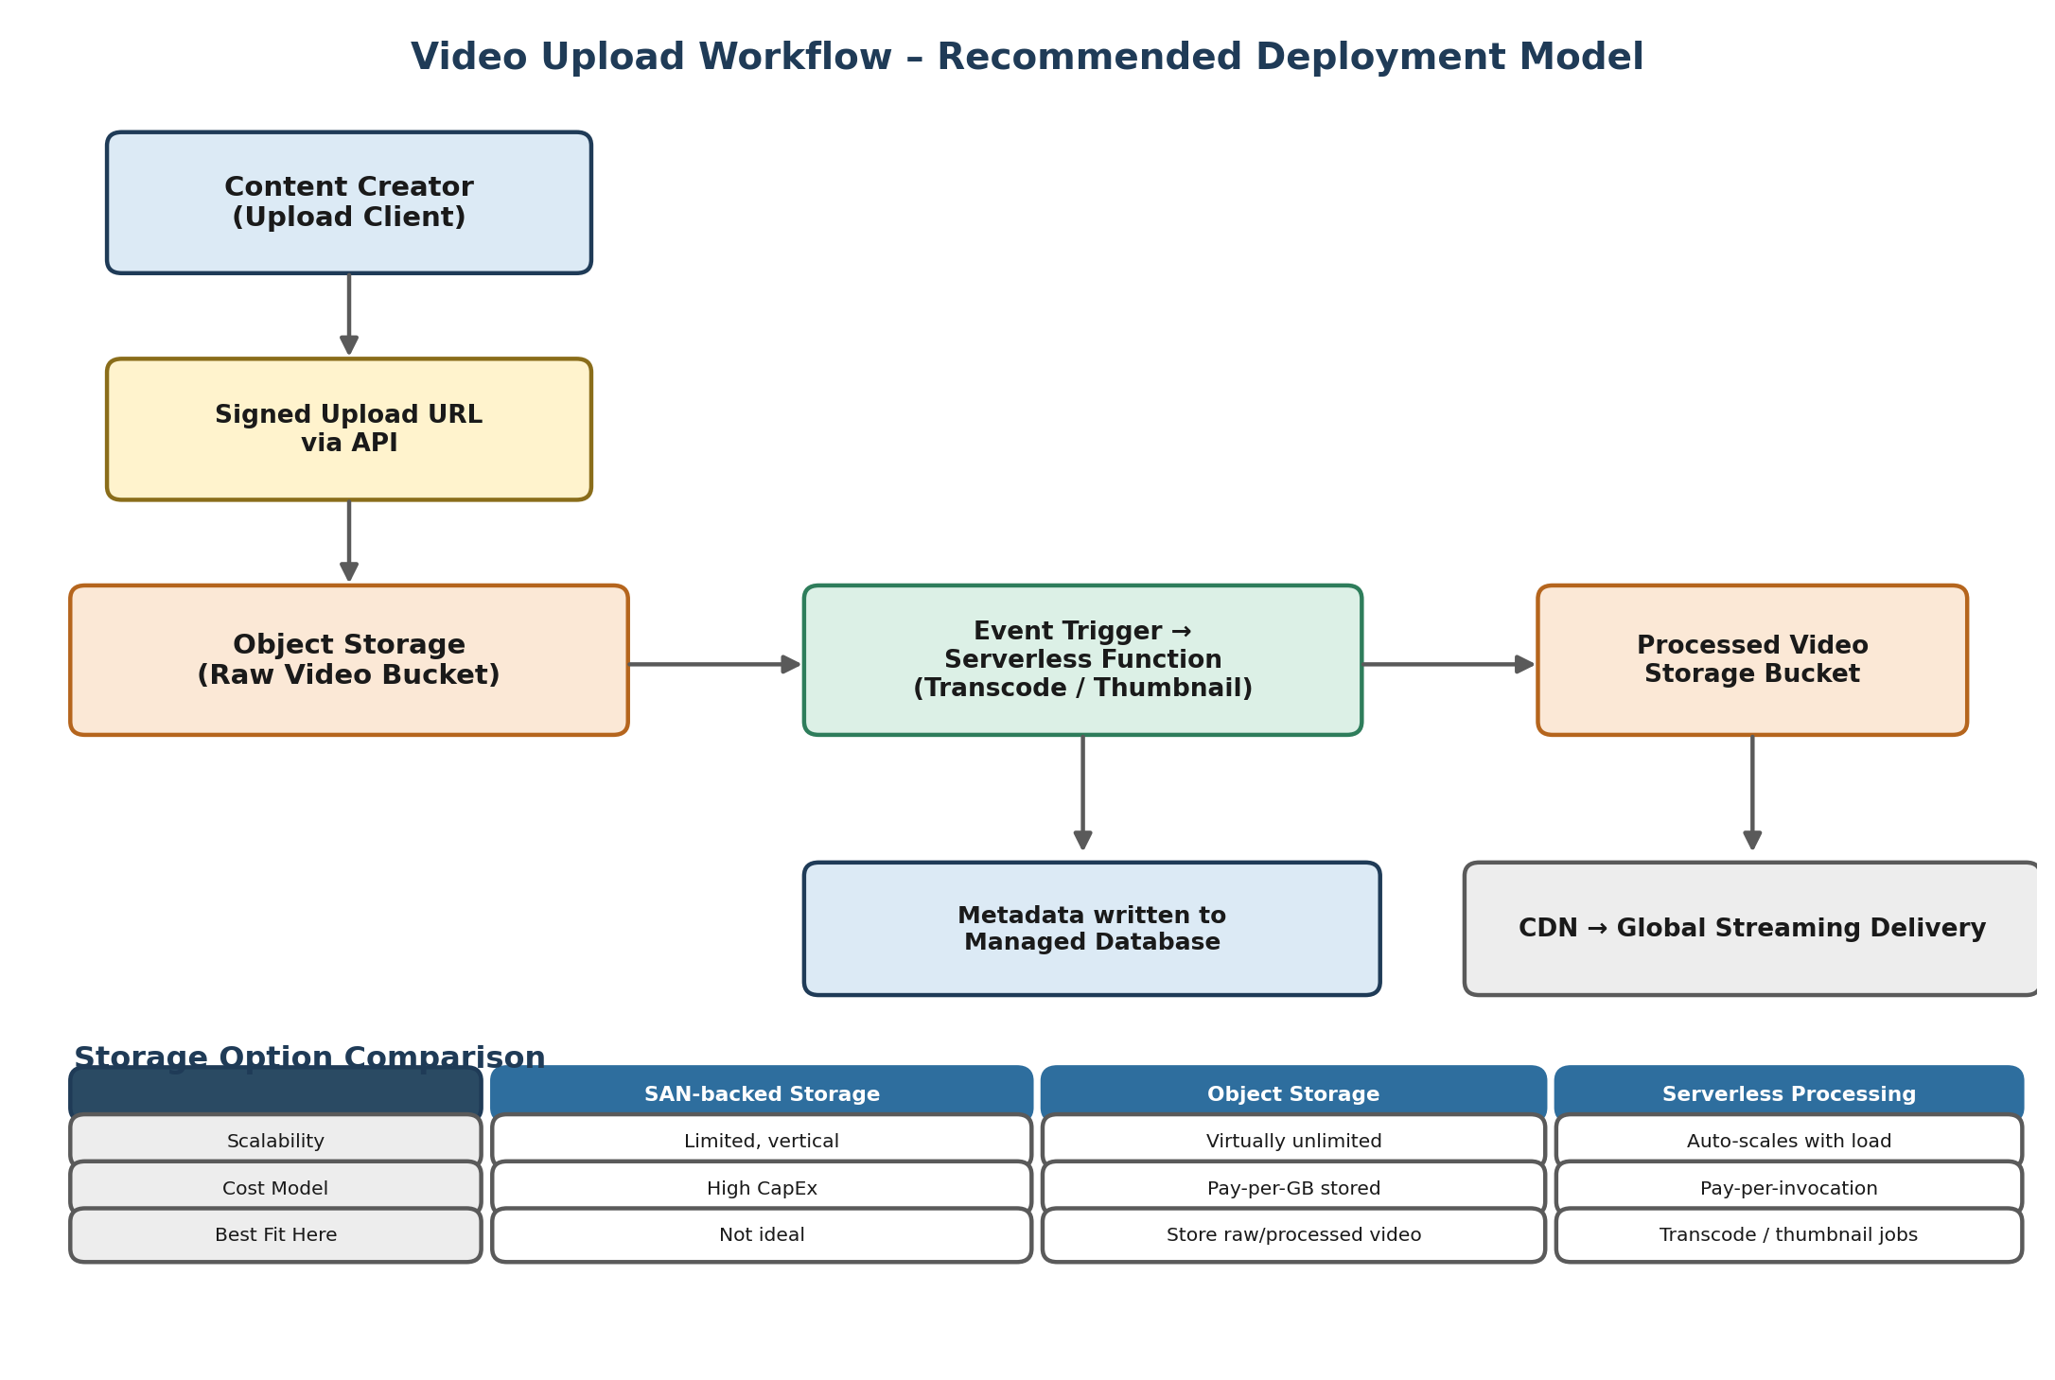
Figure 2: Recommended event-driven video upload and processing pipeline, with storage-option comparison

4. Justification / Trade-off Reasoning
- Cost efficiency: object storage and serverless functions are both pay-per-use, matching the startup's unpredictable, growth-stage workload – no idle capital expenditure as with SAN.
- Elastic scalability: as upload volume grows, both the storage layer and the transcoding functions scale automatically without re-architecture.
- Decoupled, event-driven pipeline: uploading, transcoding, and delivery are independent stages connected by storage events, so a spike in uploads does not overwhelm the processing stage – functions simply scale out.
- Global delivery: pairing object storage with a CDN gives low-latency playback to viewers worldwide, something a single SAN cannot provide cost-effectively.
- Caveat: for very long or very large video files, pure serverless transcoding may hit execution-time limits; the startup can supplement with a managed container-based transcoding service for those jobs while keeping the rest of the pipeline serverless.

Case 3: Edge and Fog Computing for a Smart City Platform

1. Understanding the Requirements
The platform must make low-latency decisions close to sensors (e.g., traffic signal control, anomaly/incident detection) where round-tripping every reading to a distant cloud data center would be too slow, while still leveraging the cloud for city-wide, long-horizon analytics such as traffic pattern modelling and predictive maintenance.

2. Role of Edge and Fog Computing
- Edge Computing: Places compute directly at or very near the sensor/device (cameras, air-quality sensors, streetlights). It performs immediate, local inference – e.g., detecting a vehicle at a junction and adjusting a signal – with millisecond-level latency and without depending on network availability to a distant cloud.
- Fog Computing: Introduces an intermediate layer of regional nodes (e.g., a fog node per district) that aggregates and filters data from many nearby edge devices, performs cross-sensor correlation (e.g., combining traffic-camera and air-quality data for a neighbourhood), and forwards only summarized/important data upward – reducing bandwidth to the cloud while still being closer to the source than a centralized data center.
- Cloud Layer: Performs the tasks that are not latency-sensitive: city-wide big-data analytics, machine-learning model training on historical data, long-term storage, and dashboards for city administrators.

3. Proposed Layered Architecture
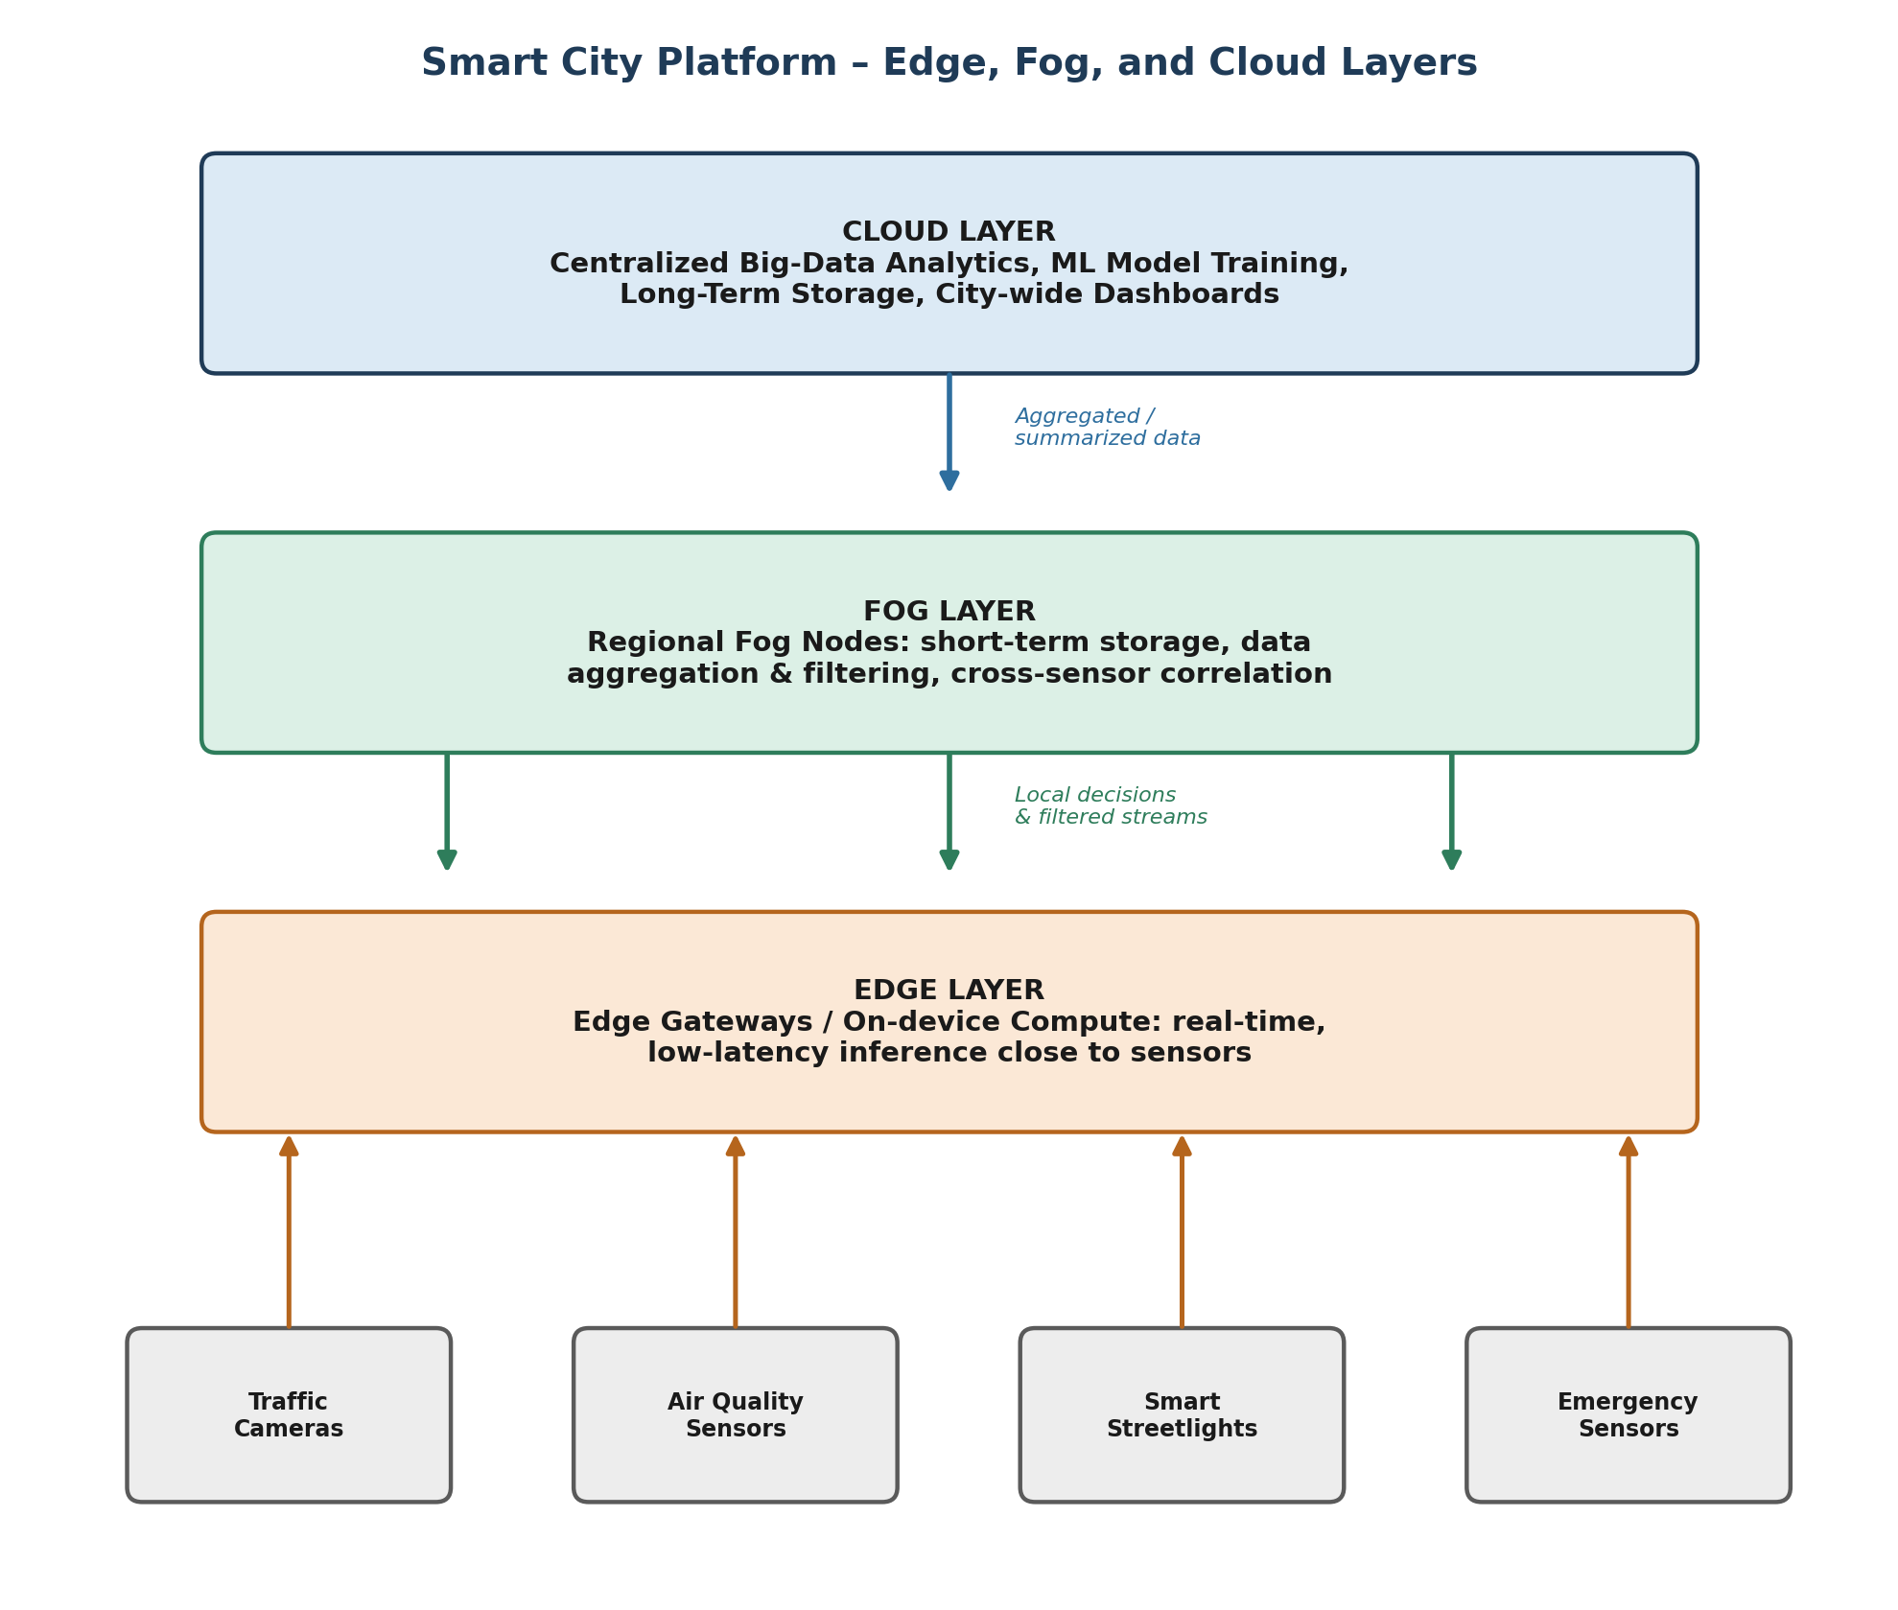
Figure 3: Three-tier Edge – Fog – Cloud architecture for the smart city platform

4. Analysis and Trade-offs
- Latency vs. centralization: edge computing minimizes latency for time-critical local decisions, at the cost of managing compute on many distributed, resource-constrained devices.
- Bandwidth vs. completeness: the fog layer reduces the volume of data sent to the cloud (only aggregated/filtered data travels upward), trading off the cloud having immediate access to every raw reading.
- Resilience: because edge and fog nodes can operate autonomously, critical local functions (like traffic signal control) continue even during a temporary loss of connectivity to the cloud.
- Complexity vs. capability: a three-tier architecture is more complex to deploy, secure, and maintain than a single centralized cloud system, but it is necessary to meet the low-latency requirement without sacrificing city-wide analytics.

5. Recommendation
Adopt the three-tier edge–fog–cloud model: use edge nodes for immediate, safety-critical local decisions; use regional fog nodes to aggregate, filter, and pre-process data for their surrounding area (reducing bandwidth and enabling neighbourhood-level correlation); and reserve the cloud for city-wide analytics, ML model training, and long-term data retention. This balances the platform's need for real-time responsiveness near sensors with its need for centralized, large-scale intelligence.

